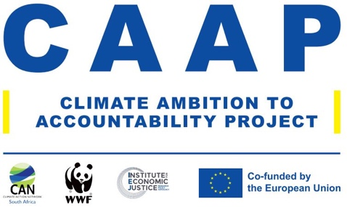

**AUTHORIZATION AND RELEASE FOR PHOTOS, AUDIO AND/OR VIDEO RECORDINGS OF, AND/OR ARTWORK FROM A MINOR CHILD SUBJECT PRODUCTION/OUTREACH PROJECT:**

**CHILDREN’S ILLUSTRATIONS & ART PERSPECTIVES CHALLENGE**

Child’s Name: (Child)……………………………………………………………………………………. (Age) …………………………….

I, …………………………………………………. (Parent /Guardian/ Caregiver) Name, hereby grant to the Presidential Climate Commission (PCC) the right to make, use, create derivative works, and/or display:

(1) photos, video and/or audio tape recordings of, my Child and/or (2) artwork (in any media, including drawings, photos, music, and video creations) created by my child and submitted to the PCC and/or in any manner or form, and for any lawful purpose at any time.

I also grant the PCC to use my Child’s name associated with such photos, recordings of my Child or with his/her artwork.

I understand that my Child may be photographed and/or video or audio taped verbatim and that the Institute may allow persons external to the Institute to view the pictures or recordings in part or in their entirety. I also understand that any artwork submitted by my Child to the Institute for the Project may be edited, reproduced, or displayed publicly at the Institute’s discretion.

I am fully aware and agree that such use of my Child’s image or artwork and name may include posting on publicly available internet sites, including JPL sites and other publicly viewable social media sites. I waive any right that I may have to review or approve of any finished products, or the uses to which such products may be applied.

I release and discharge the Institute, its employees, sponsors, and subcontractors from any liability to

me by virtue of any representation that may occur in the creation, editing or use of said photos and/or video or audio tape recordings or the editing or use of my Child’s artwork.

I have read this agreement before signing below and warrant that I fully understand its contents.

**Signature: ________________________________________________**

**Typed Name:**

**Date:**

**Address:**